Address Book Homework Assignment

Due Wednesday February 11, 2004

Assignment Overview

The goal of this exercise is to create an Address Book application able to store and retrieve any number of Names and Addresses. [Note: You can add additional information to the class if it would make this a more useable tool for yourself.]

The idea is to develop an independent Name and Address class called CNameAddress. Then use this class in a windows form application to add, store, and display the name and address when the name is selected from a ComboBox. The application will store as many names as you wish to enter into it. While the application is running each name and address is stored in a CNameAddress object contained in a collection called Names.

To simplify initial development add a class file to the windows form project. Once all functionality is in place and working. Create a separate Class Library project. Cut and paste the class VB file from the windows form project to the class library project. Build the class library project creating a dll. Add a reference to the windows form project pointing to the dll file. Add an imports statement to the windows form project pointing to the class library project. Rebuild and go…

The CNameAddress objects are stored in the Names collection with a key equal to the first name concatenated to the last name with a single space in between the two names. This key is displayed in the ComboBox and used to select the name and address to display.

The collection of name and address objects is serialized to a disk file when the application closes. When the application starts it can automatically reload the serialized file at startup if you wish. These operations can be performed automatically or in response to button clicks, which ever you prefer.

CNameAddress Class

Note the addition of the <Serializable()> to the class declaration.

<Serializable()> Public Class CNameAddress

An empty constructor can be included or not as you wish:

Public Sub New()

End Sub

The CNameAddress class contains the following fields:

Private m_LastName As String = ""
Private m_FirstName As String = ""
Private m_Street As String = ""
Private m_City As String = ""
Private m_State As String = ""
Private m_Zipcode As String = ""
Public adrKey As String = ""

Get Set Assessors are included for each of the above private fields (i.e. Public Property FirstName).

The CNameAddress class contains the following methods:

Public Function ReturnAddressLabel() As String
Dim sLabel As String = ""
sLabel = m_FirstName + m_LastName + vbCrLf
sLabel += m_Street + vbCrLf
sLabel += m_City + ", " + m_State + " " + m_Zipcode + vbCrLf
Return (sLabel)
End Function

Public Function BuildAddressKey() As String
If m_FirstName = "" Or m_LastName = "" Then
Throw New ApplicationException("Both first name and " & _
"last name are required to build the key.")
End If
adrKey = m_FirstName + " " + m_LastName
Return (adrKey)
End Function

Address Book Windows Form Application

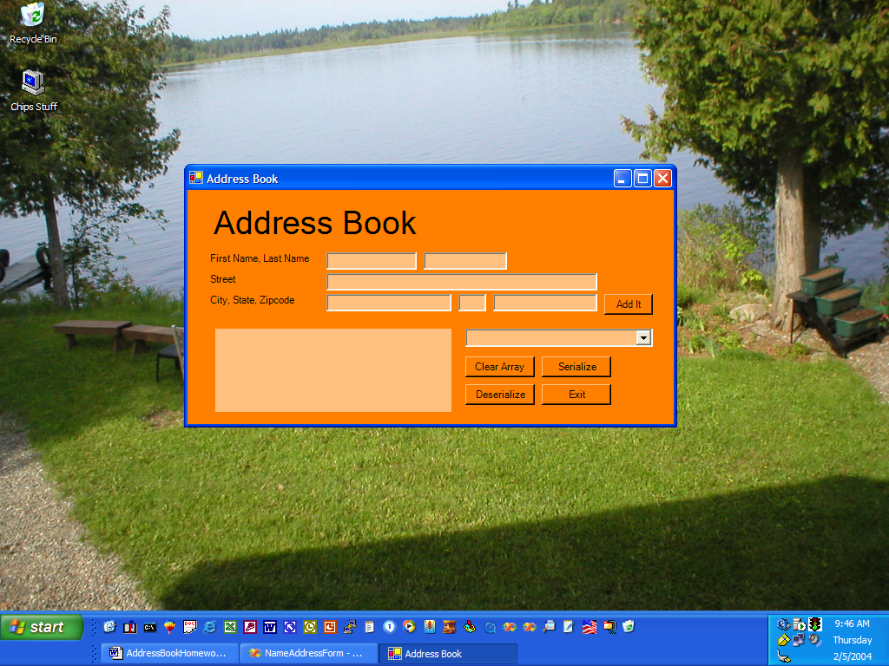

Using the above picture as a model, build a Windows Form application. Feel free to modify the design to your liking.

Include the following imports statements:

Imports NameAddressClass
Imports System.IO
Imports System.Runtime.Serialization
' Note: When building this code, you must reference the
' System.Runtime.Serialization.Formatters.Soap.dll assembly.
Imports System.Runtime.Serialization.Formatters.Soap
Imports System.Runtime.Serialization.Formatters.Binary

Declare the CNameAddress object and the Collection class within the form class, but outside of any methods.

#Region " Windows Form Designer generated code "

#End Region

Public obj As CNameAddress
Public AddressBook As New Collection

When a new name and address is entered:

- Use the data to create an instance of the CNameAddress class.

obj = New CNameAddress
obj.FirstName = TextBox1.Text
obj.LastName = TextBox2.Text
obj.Street = TextBox3.Text
obj.City = TextBox4.Text
obj.State = TextBox5.Text
obj.Zipcode = TextBox6.Text

- Create the key.

obj.BuildAddressKey()

- Add the instance (i.e. object) to the collection.

AddressBook.Add(obj, obj.adrKey)

- Add the key to the ComboBox. [Note: it helps to set the ComboBox1.Sorted = True in the ComboBox properties.]

ComboBox1.Items.Add(obj.adrKey)

When an item is selected from the ComboBox, retrieve the selected item from the AddressBook collection and display the name and address in the Label.

obj = AddressBook(ComboBox1.SelectedItem)
Label4.Text = obj.ReturnAddressLabel

Reset clears all the fields on the display.

You can use either the Soap XML or Binary formatter. The following codes uses the Binary formatter.

To serialize…

Dim bFormatter As IFormatter = New BinaryFormatter
Dim strm As Stream = New FileStream("datafile.bin", FileMode.Create, FileAccess.Write, FileShare.None)
For i = 1 To AddressBook.Count
obj = AddressBook(i)
bFormatter.Serialize(strm, obj)
Next
strm.Close()

To deserialize…

Dim fs As New FileStream("DataFile.bin", FileMode.Open)
Try
Dim bFormatter As New BinaryFormatter
While (True)
obj = DirectCast(bFormatter.Deserialize(fs), CNameAddress)
AddressBook.Add(obj, obj.adrKey)
ComboBox1.Items.Add(obj.adrKey)
End While
Catch e1 As SerializationException
MessageBox.Show("Failed to deserialize. Reason: " & e1.Message)
Finally
fs.Close()
End Try

